**Linux assignment**

Description:

Install a Linux VM over Windows system and ping them using command prompt & terminal.

Stop firewall in both the systems.

Use the Putty software to the Linux SSH.

Write a CRON job to remove all content of temporary folder every one day.

**Ping Linux machine from Windows**

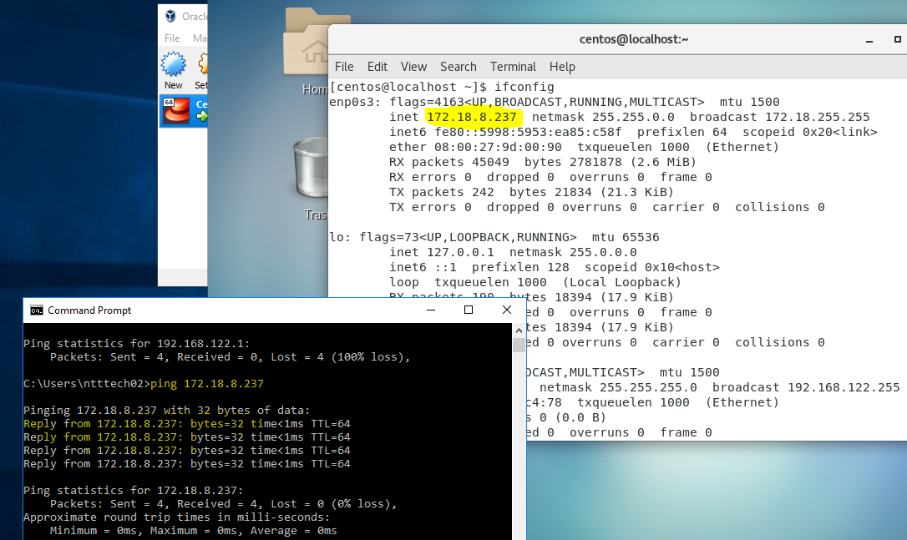

**Ping Windows machine from Linux**

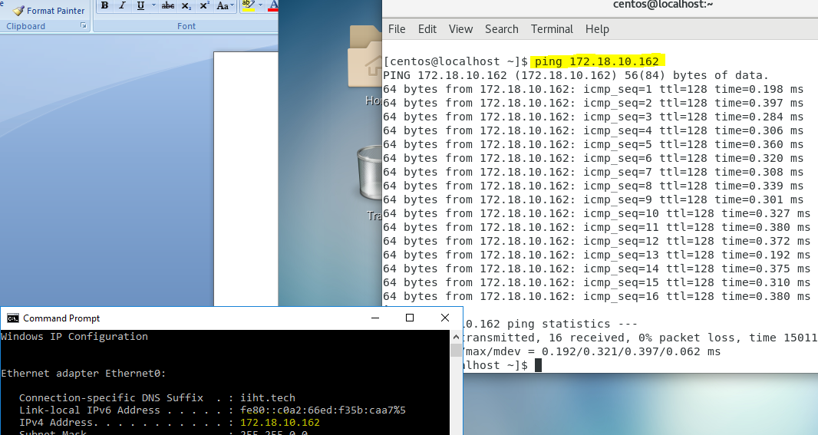

**Stop firewall on Linux**

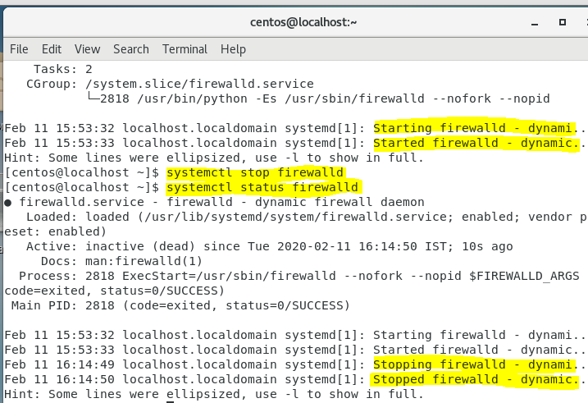

**Configure putty to connect to linux machine**

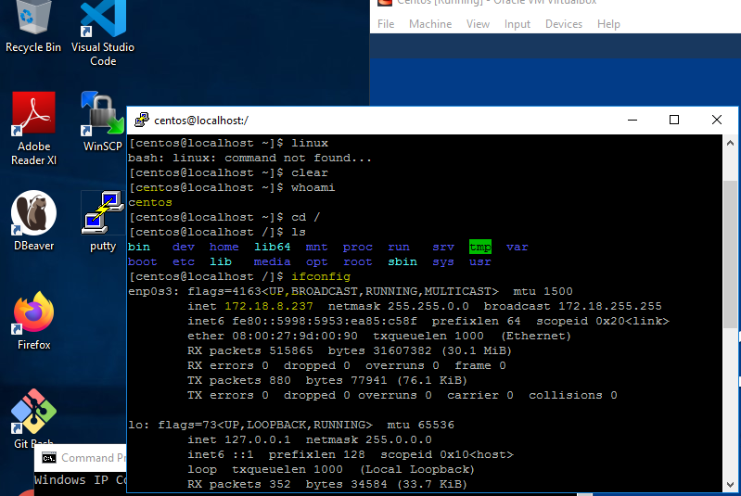

**Schedule a cron job to clean temporary files on the linux daily at 12 PM.**

1. Create a cron entry

Command : crontab –e

